Source https://deluxeiceland.is/luxury-tours/private-volcano-hike-the-blue-lagoon/
__________________________________________________________

Exclusive Volcano Hike & Blue Lagoon Tour
__________________________________________________________
★★★★★ 4.7/5 23 reviews

Add to wishlist ♡

__________________________________________________________

8-10 hours | From €823 per person

🏕  Image | 🏕  Image | 🏕  Image | 🏕  Image | 🏕  Image | 🏕  Image

__________________________________________________________
About This Tour
Get ready for an incredible private day tour that combines adventure and relaxation in Iceland. This tour takes you to the Reykjanes Peninsula, where you’ll hike to the site of the 2021 volcanic eruption, where you can see the new lava fields formed by one of the most recent eruptions in Iceland. After your exciting hike, head to the world-famous Blue Lagoon to relax in the rejuvenating geothermal waters. Enjoy access to the Retreat Spa, unwind in the soothing waters, and recharge. Your tour ends with a comfortable return to your hotel in Reykjavik.
__________________________________________________________
What’s Waiting for You
- Duration: 8 - 10 hours
- Group Size: Private group, ideal for families, couples, or small groups
- Accommodation: Not applicable (Day tour)
- Languages Available: English
- Private Guided Tour: Fully personalized experience with your own expert guide
- Transportation: Luxury vehicle with Free Wi-Fi and bottled Icelandic water on board
- Season: Available year-round
__________________________________________________________

Check Dates & Availability

Select participants: (Age 99 and younger) - 1 +

Choose date:
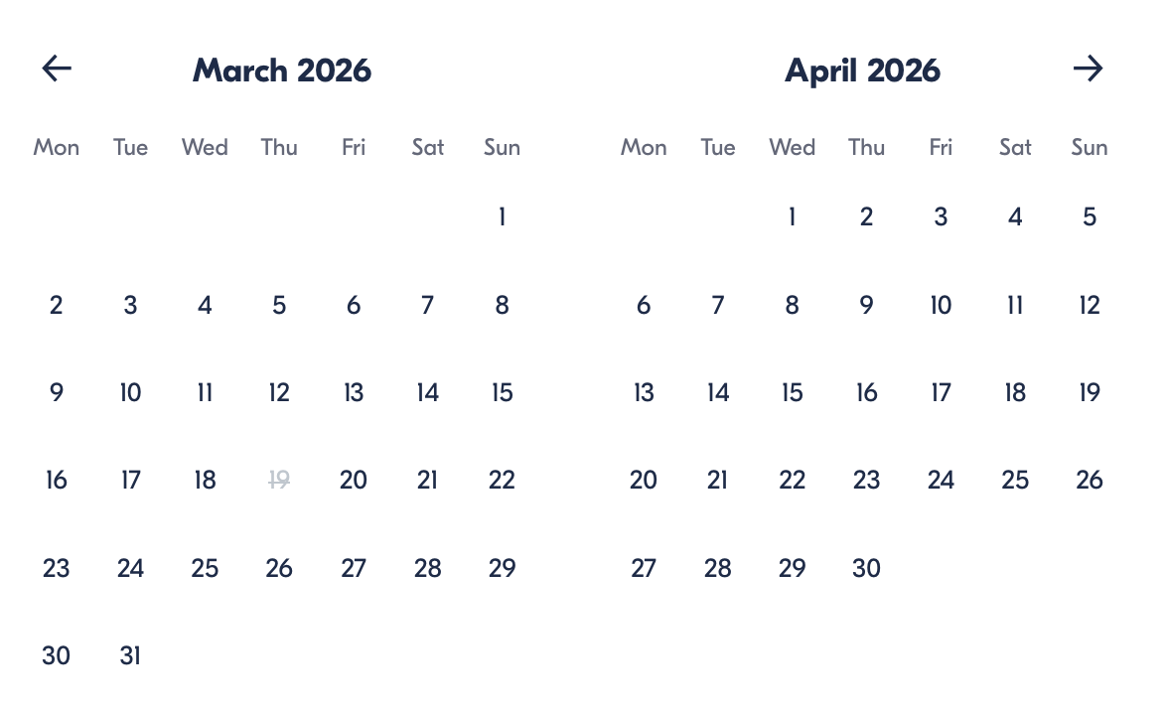

Check Availability

opens:

Participants: 2 March 16, 2026

Exclusive Volcano Hike & Blue Lagoon Tour

- Duration: 8-10 hours
- Offered in: English
- Starts at: 10:30 AM

Cancellation:

- More than two weeks prior to arrival: 40% Credit / 60% Refunded
- Less than two weeks prior to arrival: 50% Credit / 50% Refunded
- Less than 72 hours prior to arrival: No refund and no credit

Price breakdown: 2 Participants x €823

Total: €1,646

The total price includes all taxes and fees.

Add to cart Book now

__________________________________________________________
Tour Features
- Reykjanes Peninsula: Hike to the 2021 volcanic eruption site and see the new lava fields.
- Blue Lagoon: Soak in the world-famous geothermal waters with access to the Retreat Spa.
- Private Vehicle: Enjoy a comfortable ride with free Wi-Fi and bottled Icelandic water.
- Expert Guide: Your guide will provide fascinating insights into the volcanoes and Iceland’s unique geothermal landscape.
- Pick-up & drop-off in Reykjavík.
__________________________________________________________
Detailed Itinerary
- Day 1 – Volcano Hike & Blue Lagoon Relaxation
Your adventure starts with a morning pickup in Reykjavik. Drive to the Reykjanes Peninsula, where you’ll begin your hike to the site of the 2021 volcanic eruption. The hike will take around 1 to 2 hours, depending on how close you want to get to the new lava fields. Your guide will explain the significance of this eruption and Iceland’s volcanic activity, making this hike both thrilling and educational.
After the hike, relax and unwind at the Blue Lagoon, where you’ll have exclusive access to the Retreat Spa. Spend time soaking in the warm, healing waters surrounded by stunning volcanic landscapes. Take a break in the spa’s quiet lounges, or enjoy a meal at the on-site restaurant if you wish.
After a truly relaxing experience, your private driver will take you back to Reykjavik, where the tour ends.
__________________________________________________________
Included in Price
- Private guide for the entire tour
- Luxury vehicle with free Wi-Fi and bottled Icelandic water
- Hike to the volcanic eruption site
- Exclusive access to the Blue Lagoon Retreat Spa
- Private transfers between all destinations
- All taxes and fees – no hidden charges
__________________________________________________________
Not Included
- Meals (Lunches and dinners are not included)
- International flights
__________________________________________________________

Cancellation Policy
For 5 or Fewer Participants:
- More than 2 weeks before arrival: 40% Credit / 60% Refund
- Less than 2 weeks before arrival: 50% Credit / 50% Refund
- Less than 72 hours before arrival: No refund or credit
For 6 or More Participants:
- More than 4 weeks before arrival: 40% Credit / 60% Refund
- Less than 4 weeks before arrival: 80% Credit / 20% Refund
- Less than 2 weeks before arrival: No refund or credit
Changes in the number of participants may increase the price per person. We recommend comprehensive travel insurance.
Weather-Related Cancellations:
If activities are canceled due to weather, they will be fully refunded. Itineraries may change based on conditions, with safety as the top priority.
Refund Processing:
Refunds are processed within 15 days after the tour ends.
__________________________________________________________
What Our Clients Are Saying

Overall rating  4.7/5  ★★★★★  Based on 23 reviews | Review summary  Guide 4.5/5  Transportation 4.6/5  Service 4.7/5  Organisation 4.5/5

Filter  - All traveller types  - Couples  - Group of friends  - Families  By star rating  - All star ratings  - 5 stars  - 4 stars  - 3 stars  - 2 stars  - 1 star | Search reviews (e.g., guide)  Sort by:  - Top picks  - Latest reviews  - Best ratings  - Lowest ratings
__________________________________________________________
★★★★☆
Marc – France
Une aventure incroyable ! La randonnée jusqu’au site volcanique était un peu difficile, mais cela en valait vraiment la peine. La baignade dans le Blue Lagoon a été un moment parfait pour terminer la journée.

★★★★★
Leanne – Germany
This was the most amazing experience! Hiking to the volcanic site was exhilarating, and the Blue Lagoon was the perfect way to relax afterward. Our guide was fantastic, and everything was seamless.

★★★★★
Sophie – Canada
Such an incredible day! The hike was challenging but worth it for the views of the lava. The Blue Lagoon afterwards was like heaven. Highly recommend this tour!

See more reviews
__________________________________________________________

Meta tags

Page - Exclusive Volcano Hike & Blue Lagoon Tour

Title: Exclusive Volcano Hike & Blue Lagoon Tour | Travellio Global

Description: Experience the best of Iceland on this private adventure, hiking to a volcanic eruption site and relaxing in the healing waters of the Blue Lagoon. Enjoy a personalized, unforgettable day with your own guide and luxury transportation.

H1 - Exclusive Volcano Hike & Blue Lagoon Tour
__________________________________________________________

